General membership meeting
OPSEU Local #352
Date: September 29, 2022
Time: 12 Noon
Location: ZOOM
Call to order: 2
Reminder – Townhall with bargaining team 2
Land Acknowledgement: Liz 2
Reading of Statement of Respect: Suzanne 2
Adoption of Agenda: 2
Consent agenda items 2
Treasurer’s Report 2
MOTION TO ACCEPT THE TEASURER’S REPORT 3
Minutes of the previous GMM meeting: 3
Business arising 3
Bargaining Update 3
Reports/Unfinished Business requiring action: 3
AUCC report 3
WMG report 4
College Employment Stability Committee (CESC) report 4
Joint Employment Stability Reserve Fund (JESRF) update 4
New Business: 4
Local Elections: 4
Nominations for Officers: 5
President – Liz Mathewson 5
Vice President – Suzanne Hooke 5
Chief Steward – Audrey Healy 5
Treasurer – Amanda Rochon 5
Secretary/Communications - Victoria Maystruk 5
Motion to approve release time and stipends for officers 5
MOTION: Accept the stipends as they currently are and bring possible changes back for discussion at the next GMM. 6
Trustee Nominations: Fred Wood & Derryk Pollard 6
Election of Delegates/Alternates and Observers for Divisional Meeting 6
3 Delegates: Local President: Liz Mathewson, Suzanne Hooke, Audrey Healy 6
3 Alternates: Victoria Maystruk, Andrew Bohart, Fred Wood 6
Observers: Tom Jenkins, Karen Bateman, Kari Draker-Fortis, Nancy Sukornyk, Richard Hyde, Mandy Rochon 6
Kaplan Award 6
Items from membership: 8
Motion to support the TSSA striking workers added under new business 8
Adjournment Next Meeting- 8

Call to order:
12:02pm

Reminder – Townhall with bargaining team

Land Acknowledgement: Liz
We would like to begin by acknowledging the Indigenous Peoples of all the lands that we are on today. While we meet today on a virtual platform, I would like to take a moment to acknowledge the importance of the lands, which we each call home. We do this to reaffirm our commitment and responsibility in improving relationships between nations and to improving our own understanding of local Indigenous peoples and their cultures.
From coast to coast to coast, we acknowledge the ancestral and unseeded territory of all the Inuit, Métis, and First Nations people that call this land home.
In particular, I would like to express our gratitude to the Mississauga peoples for allowing us to continue the work of Local 352, in their territory.

Reading of Statement of Respect: Suzanne
https://opseu.org/wp-content/uploads/2014/04/Statement-of-Respect-2019.pdf

Adoption of Agenda:
Does anyone have any items they would like to add to the agenda?
- Motion to support the TSSA striking workers added under new business

Consent agenda items

Treasurer’s Report
Current Trustees – Fred Wood and Deryck Pollard
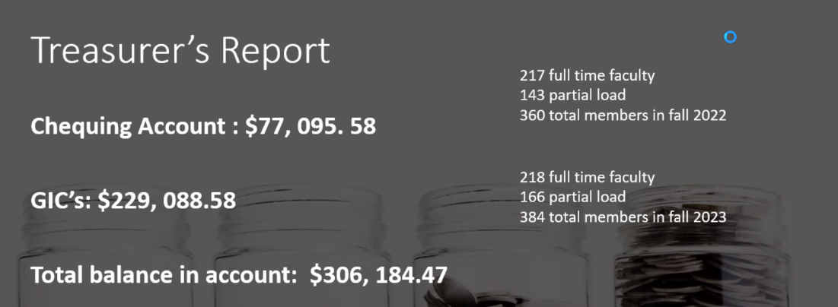
Highest balance that we have had in a while since we didn’t need the funds for a strike, and we have been meeting virtually.
One revenue stream that we have is local dues and the local dues haven’t changed for many years. FT faculty pay $8/month. PL pay $4/month.
The membership numbers in the screenshot above should be comparing Fall 2022 to Fall 2021. It’s hard to compare if the ‘amount of PL’ is higher or lower since we don’t know how many hours each PL member is receiving

MOTION TO ACCEPT THE TEASURER’S REPORT
Moved: Karen Bateman Seconded: Nancy Sukornyk
Passed

Minutes of the previous GMM meeting:
https://flemingfacultyunion.files.wordpress.com/2022/09/minutes-of-general-membership-meeting-january-17-2022.pdf

Business arising

Bargaining Update
Meeting on Thursday at 6:30 and meeting on Monday at 6:30pm

Reports/Unfinished Business requiring action:

AUCC report
Audrey
AUCC aims to bring issues that impact faculty, or issues that impact students and in turn impact faculty. AIm to get resolution without having to take concerns to a grievance.
Recently we haven’t been getting into problem solving, but rather the College acknowledges the concern and takes it away.
At the September meeting we brought up start-up issues and the College asked us to be more specific. Indicated that we felt it was across many divisions – RO, Financial Aid, AO. We made it clear that the issue wasn’t with the personnel working in the departments, but chronic understaffing. The college claims that hires have been made, however these were made right at the end of August
Bookstore ordering was misaligned with our academic schedule. Student bought textbooks that they don’t need.
Contract faculty were working without contracts and IT access.
We heard that there is a Chair doing performance review on post-probationary faculty. There is nothing in the CA to support this and the tool being used is one that has been proven to be prone to racial and gender bias.
Q: What duplicating discussed?
A: Yes – had a one-on-one with the VP of HR about the extra work and disruption about this. We will put this on the agenda for October again. We have heard that we have an account at Staples and also that we aren’t allowed to use the accounts at Staples. We have also heard that the Scantron machine was removed.
NOTE: Heard that there is a machine in Trades and Technology. One faculty has reached out about using the scantron and was told that they are not allowed to use it.
Faculty have 2 hours below the line for Routine Office Administration work and this time gets used up quickly.

WMG report
Suzanne
There was a workload complaint and during the proceses the arbitrator indicated that the settlement desired was outside the scope. Looking at resubmitting the complaint as a grievance.
Instance where a SWF had a guided learning hour and this is something that isn’t allowed under the CA.
Modified Workload Agreement – used at Fleming more than other colleges. Used mostly at Frost. There are 13 this Fall and these allow students to participate in things like camps.
We are in discussions in the College about FT faculty working in ConEd. This could be possible with the use of MWAs. The college has been cancelling course that we believe FT faculty members could be teaching.
We currently have an extra column on our SWFs that isn’t covered by the collective agreement (delivery). Looking at next steps.

College Employment Stability Committee (CESC) report
Audrey
A committee that is described in the CA. Exists to manage bumping if necessary (it hasn’t been). It also manages a Joint Employment Stability Fund

Joint Employment Stability Reserve Fund (JESRF) update
The fund has a cap of $500,000 and then it doesn’t need to be funded anymore. We are at a surplus. This fund can be used to provide retraining for faculty if their program is suspended. If you are in this situation, please contact Liz an/or Audrey for more information.

New Business:

Local Elections:
The nomination form was sent out prior to meeting. The following nominations were received.
Liz Mathewson, Suzanne Hooke, Audrey Healy, Karen Bateman, Victoria Maystruk, THomas Jenkins, Marikka Williams, Richard Hyde, Charlie McGee, Amanda Mushynski, Nancy Sukornyk, Amanda Rochon, Kari Draker-Fortis, George Fogarasi, Ann Hines, Jenny Leyderman
The floor is open for anyone else who would like to be nominated.
Troy Lesgreskey was nominated but was not present to accept or decline the nomination.
All nominated stewards are acclaimed.
The union would like to acknowledge and thank Marylou Lummiss and Thom Luloff for their work in the past.

Nominations for Officers:

President – Liz Mathewson
Moved by Audrey Healy, Seconded by Richard Hyde
Accepted and Acclaimed

Vice President – Suzanne Hooke
Moved: Fred Wood. Seconded: Karen Bateman
Accepted and Acclaimed

Chief Steward – Audrey Healy
Moved: Nancy Sukornyk, Seconded: Charlie McGee
Accepted and Acclaimed

Treasurer – Amanda Rochon
Moved: Liz Mathewson , Seconded: Kari Draker-Fortis
Accepted and Acclaimed

Secretary/Communications - Victoria Maystruk
Moved: George Foragasi, Seconded: Nancy Sukornyk
Accepted and Acclaimed

Motion to approve release time and stipends for officers
The collective agreement indicates that the College and the union should be able to come to agreement with the college. If they aren’t able to agree, then we are able to purchase the hours
Fr the first 15 hours that we purchase we pay 25% for the hourly wage
For 16+ we pay 50% of the hourly wage.
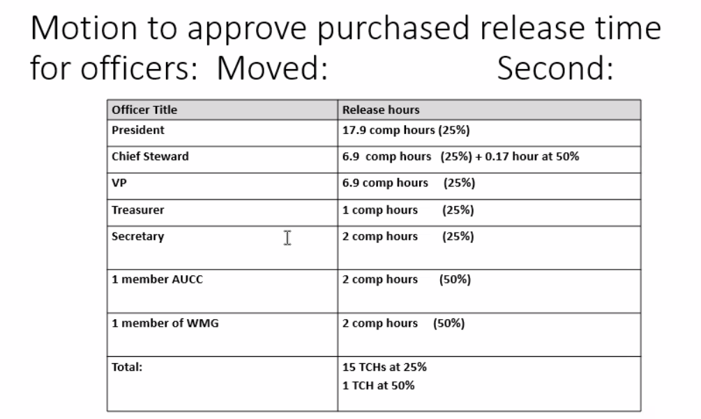
Moved: Richard Hyde, Seconded: Nancy Sukornyk
Accepted
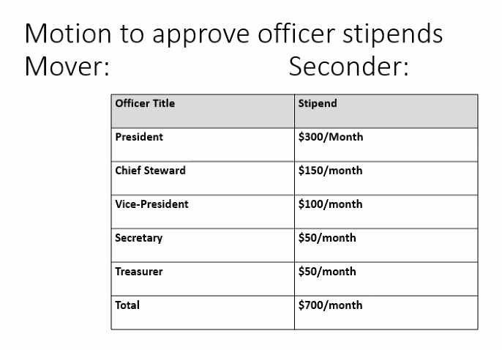
Moved: Charlie McGee, Seconded: Richard Hyde
Discussion:
We know that the number of grievances has gone up. Does the stipend still capture the work involved?
Should the stipend for the president and chief steward (and possible other officers) go up to represent the additional work?
The stipend and release time varies by local and is something that is not standard across the the different colleges.
It might be useful to consider if a stipend is more useful or if release time would be more beneficial.

MOTION: Accept the stipends as they currently are and bring possible changes back for discussion at the next GMM.
Passed

Trustee Nominations: Fred Wood & Derryk Pollard
Acclaimed and Accepted

Election of Delegates/Alternates and Observers for Divisional Meeting
Our division (24 colleges across the province) meet once a year to elect representation for OPSEU events.
We are allowed 3 delegates, 3 alternates and as many observers as we would like.
The virtual meetings that have happened in the past have been run flawlessly.

3 Delegates: Local President: Liz Mathewson, Suzanne Hooke, Audrey Healy

3 Alternates: Victoria Maystruk, Andrew Bohart, Fred Wood

Observers: Tom Jenkins, Karen Bateman, Kari Draker-Fortis, Nancy Sukornyk, Richard Hyde, Mandy Rochon

Kaplan Award
We were awarded language that we wouldn’t have gotten otherwise. It has improvements that improve the contract from an extension and doesn’t have any concessions.
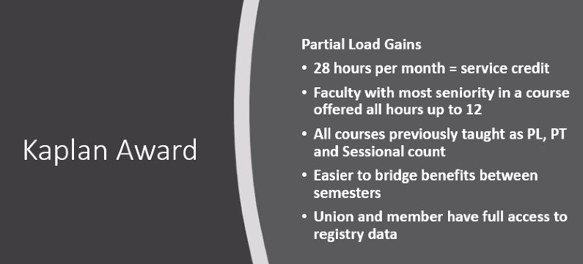




Items from membership:

Motion to support the TSSA striking workers added under new business
Would like to motion that Local 352 donate $1000 $5000 to the TSSA workers. These workers are part of a new local and don’t have an established bank account as our local has.
Moved by Audrey, Seconded by Suzanne
Discussion: We have $300,000 and these locals have none. Often we are asked for strike donations for locals who have been established. Friendly amendment – increase amount to $5000.
PASSED

Adjournment Next Meeting-
Suzanne at 1:23pm

