 GMM

General Membership Meeting

OPSEU Local #352

Date: Wednesday, August 28, 2024
Time: 12:30-2:30 p.m.
Location: In person B3 150 & Remote (43 members online & 46? in person)

LEC Attendees:
 | Victoria Maystruk | Jenny Leyderman | Tom Jenkins
 | Karen Bateman | Amanda Rochon | Amanda Mushynski
 | Troy LeGresley | Kari Draker-Fortis | Nancy Sukornyk
 | Audrey Healy | Tom Churchill | Kim Bell
 | Charlie McGee | Marikka Williams
ABSENT:
Andrew Bohart
Mike Benedict

Call to Order: Meeting began at 12:45 p.m.

Meeting adjourned at 2:45: Moved: Karen Bateman Seconded: Kari Draker-Fortis

Adoption of Agenda: Moved: Nancy Sukornyk Seconded: Fred Wood

Minutes from Previous GMM: Moved: Tom Churchill Seconded: Charlie McGee

Business Arising - Stewards Update

Victoria Maystruk Jenny Leyderman – Partial Load contract not renewed
Karen Bateman Andrew West – declined part-time contract
Audrey Healy George Fogarasi – Sabbatical (returns September 2025)
Nancy Sukornyk Jason Jackson – resigned; pursing private industry work
Kari Draker-Fortis
Charlie McGee
Amanda Rochon
Amanda Mushynski
Marikka Williams
Thom Jenkins
Tom Churchill
Andrew Bohart
Kim Bell
Mike Benedict
Troy LeGresley

Business Arising – Milestones
41 members celebrating 5-, 10-, 15- & 20-year milestones this year. Celebration is planned for December/January.
Treasurer’s Report
- Working on Treasurer Audit Report (TAR) for Jan-Jun 2024
- Changes that will impact finances for fall and subsequent terms:
  - Increase in money spent on union release hours (College no longer funding some release hours as in the past)
  - Reduction in Partial Load faculty will impact union dues we collect
  - MOTION: Raymond Yip Choy put forward a motion to increase union dues to $8/pay. We had quorum, but those present decided it’s best to continue the discussion at the next GMM when we have more information about impact on our numbers (e.g. impact of reduction in Partial load faculty)
  - All were in favour to discuss at next GMM.
    - Closure: Charlie McGee Seconded: Steve Benns

AUCC Report
- 2024-2026 members: Vikki, Karen (co-chair), Kari, Kim
- Alternate: Amanda M
- Concerns are not being heard by the college
- New format of discussion-decision process to mitigate ongoing talks that continue for months without resolution
WMG Report
- 2024-2026 members: Vikki (co-chair), Karen, Andrew, Troy
- Alternate: Nancy
  - Increase in WMG referrals for Fall
  - 11.02 A 2 – revision must be discussed with faculty prior to assigning work
  - 5 days to refer ANY new SWF to WMG
  - Ensure management is fulfilling duties/management functions
  - Concerns around hiding work by not putting it on a SWF
  - This effects contract faculty/membership at large
  - Laura Gunning – new Chair (replacing Lorie Blundon)
  - Faculty are encouraged to discuss any SWF issues with Chair first and then proceed to WMG if not resolved.
College Employment Stability Committee Report
  - 2024-2026 members: Vikki, Karen, Audrey (co-chair), Kari
    - Continuing to meet regularly this semester
    - Go back to weekly mailchimp reports
  - Joint Employment Stability Reserve Fund (JESRF) update
Grievance Report
- Grievances have increased across the board
- Group grievances involve 2 or more people with same issue
- Current issue with number of arbitrators – 8-9 arbitrators are shared by academic and support staff members. This has caused increase in delays and with not enough arbitrator hours available, some grievances may take up to a year to resolve.

School/Membership Report - Mobilizing Strengths and Challenges

Charlie encouraged members to volunteer their time, based on their interest and skill set, with mobilization in the following areas: social media, graphic design, writing, researching articles etc.

He then asked members to share their current concerns:

- Changes in scheduling without informing faculty via email.
- Electrical Engineering (Warren) had 3 concerns:
  - Management increased numbers in labs without listening to faculty concerns.
  - Full-time faculty are retiring with no new hires.
  - High turnover of management – currently an Acting Chair for Trades
- Development time is not being approved unless it’s during downtime. There’s been no approval for re-development of fall/winter semesters.
- Lack of clarity around first day of classes (Tuesday after Labour Day) & Orientation.
- Part-time faculty are being asked to develop courses. E.g. 6 hours of teaching with sometimes 30+ hours of development work - exploitation of labour.
- Concern about class sizes increasing and not enough chairs/space to accommodate students. Marikka is on the Health & Safety committee and asked members to contact her, if needed.
- Microcredentials – some are being developed but it’s unclear who is developing them.

These concerns are unique to Fleming and not shared by the 23 Ontario colleges.

New Business

Bargaining updates
  - www.collegefaculty.org
  - Workload Taskforce Report
Bargaining Town Hall
- When: August 28th, 6-7:30pm
- Where: Zoom
- Register here: https://opseu-org.zoom.us/webinar/register/WN_-7j8QQfvTpGWrq9JM73E4g

Agenda
6-6:10pm - Welcome, Statement of Respect, Land Acknowledgement
6:10-7pm - Bargaining Presentation
7-7:30pm - Question & Answer Period
The Bargaining Presentation portion of the webinar will include:
A bargaining summary from July,
Updates on the Workload Taskforce Report release,
Preparations for our Day of Action on September 9
Local organizing and preparedness for any labour action
A Question & Answer period will follow the Bargaining Presentation.
If you have any questions, please contact bargainingteam2024@gmail.com

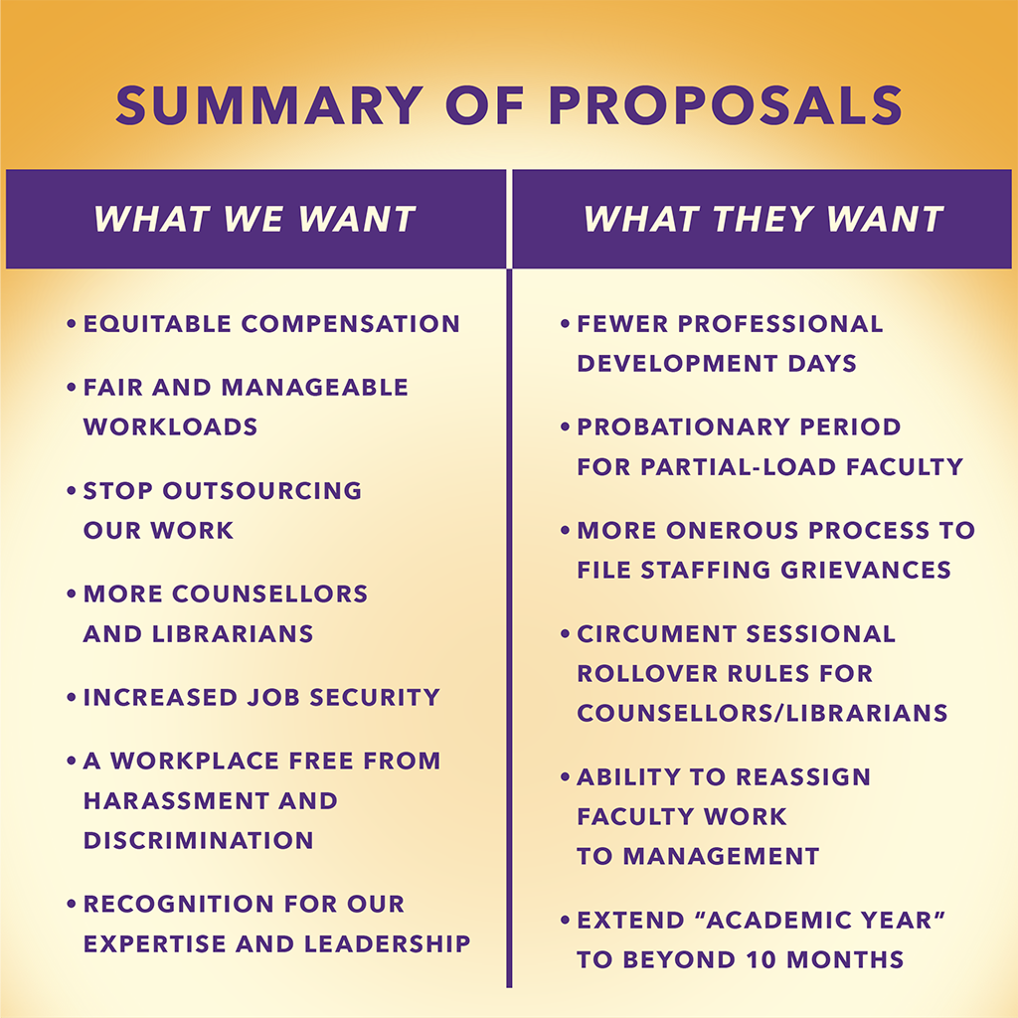

What is a Strike Vote?

Our current contract ends on September 30, 2024. Vikki briefly explained the benefits of a strike vote, if necessary, to put pressure on management to negotiate in good faith and to avert a strike.

Purpose of a Strike Vote:
- A strike vote is conducted to authorize union members to go on strike if contract negotiations with management fail.
- It does not guarantee a strike but gives the union the authority to initiate one if necessary.
Voting Process:
- Union members cast their votes to either approve or reject the strike authorization.
- A majority vote in favor is required to authorize a strike.
Impact of a Strike Vote:
- A successful strike vote can put pressure on management to negotiate more earnestly.
- It can also serve as a momentum builder, showing solidarity among union members

New Business

Unionization of part-time/partial load faculty

Partial Load/Part-time contracts
- 82 partial load
  - last year, it was approx. 400-500
  - Main programs given P-L: Nursing, Trades (Apprenticeship) & Coordinators
- 476 part-time

Role of part-time faculty during work action

