
General Membership Meeting

OPSEU Local #352
Date: April 30th, 2026
Time: 11am-1pm (adjourned at 12:43 p.m.)
Location: Westdale United Church, Peterborough ON

This is a hybrid event. Online participants can use the following link to participate: https://us02web.zoom.us/meeting/register/FZITPfstScycTOj1cnEtEg

LEC Attendees:

Kim Bell Ann Hines
Nancy Sukornyk Andrew Bohart
Mike Benedict Melissa McQuaid
Kari Draker-Fortis Brittany Gerris
Brittany Gerris LeeAnn Fenlon
Chris Summerville Lisa Kraemer
Jesse Melo Charlie McGee
Tom Jenkins Mandy Rochon

Regrets:
Tom Churchill
Anita Arnold

In person participants: 16
Online participants: 30

- Call to Order – Kim began the meeting at 11:20 a.m.
- Statement of Respect
- Land Acknowledgement
- Adoption of Agenda Moved: Chris Cole Seconded: Charlie McGee
- Approval of Past Minutes Moved: Kari Seconded: Mark
March 2026 Minutes

- New Business

  - Treasurer’s Report
- July – Dec 2025 Trustees' Audit Report (TAR) approved and submitted to Regional Office
  - Done every 6 months
  - Thank you to Fred and Derrick who complete the final approval
  - Receive rebates from OPSEU
- Online banking via Scotia Connect (requires 2 approvers) is in the works and will be set up before summer
- Financial Snapshot:
  - Basic Business Account as of April 30th, 2026: $132 278.07
  - GIC Investments as of March 31st, 2026: $327 824.66

Kari put forward a Motion to purchase union laptops

- I would like to pass a motion for the union to purchase up to 4 laptops for union business, not to exceed $5000.
- Rationale: laptop use for union business and to access information when members are attending AUCC, WMG, CESC etc.
- We currently have no union laptops.

Details:
- One for president use
- One-two flex laptops – for use during union-related meetings, notetaking, grievances
- For union business only; no file storage or personal information stored on laptops
- Laptops would be stored in union office

Motion: That Local 352 purchase up to 4 laptops for union business.
Moved by: Kari Draker-Fortis
Seconded by: LeeAnn Fenlon
Decision: Carried

  - Merger Discussion

Unfair Labour Practice (ULP) Filed

- On April 28th, a ULP was filed to employer, including impact statements
- Premise of ULP is based on violations of the Colleges Collective Bargaining Act (CCBA)
- ULP included:
  - Freezing of merger plans between Fleming & SLC
  - Freezing of planned layoffs/staffing changes

Letter of Understanding: New or Merged College

Joint Task Force includes representatives from:
    - Affected Colleges
    - OPSEU Locals
    - New/Merged College
    - CEC & Provincial OPSEU
    - Mike Benedict will represent Fleming

What the Task Force Does:
- Supports employee movement
- Develops transition strategies
- Assists adjustment for transfers
- Helps with reassignment if not transferring

Key Reality:
- Many details depend on future program decisions
- A process for managing workforce transition
- Not a mechanism to stop mergers

  - Employment Stability

Trend Overview: Faculty Staffing (2023-2025
- Dramatic decrease in PL/FT compliment in 3 most recent academic years
  - -78% Fall; -68% Winter (PL)
  - -20% (FT)
- Increase in PT Contracts in 3 most recent academic years
  - + 64% Spring/Summer Semester
  - + 96% Fall Semester
+ 45% Winter Semester
- Decrease in Partial Load Contracts; steep erosion over past 3 years
- Working on accurate number of part-time contracts
- Once we have CA for part-time members, we will have accurate data & numbers
PT Onboarding
- Solidarity fund to support part-time onboarding; Local had dedicated 150 hours
- We are between 14 & 17% of target
- OPSEU target is ~80% to have CEC fully engaged during bargaining
- Particia Tuff – chair of part-time & sessional division (part-time at Fleming and Humber)
- Pre-bargaining dates began on April 28th & 29th
- Continue to speak with colleagues about signing EMF
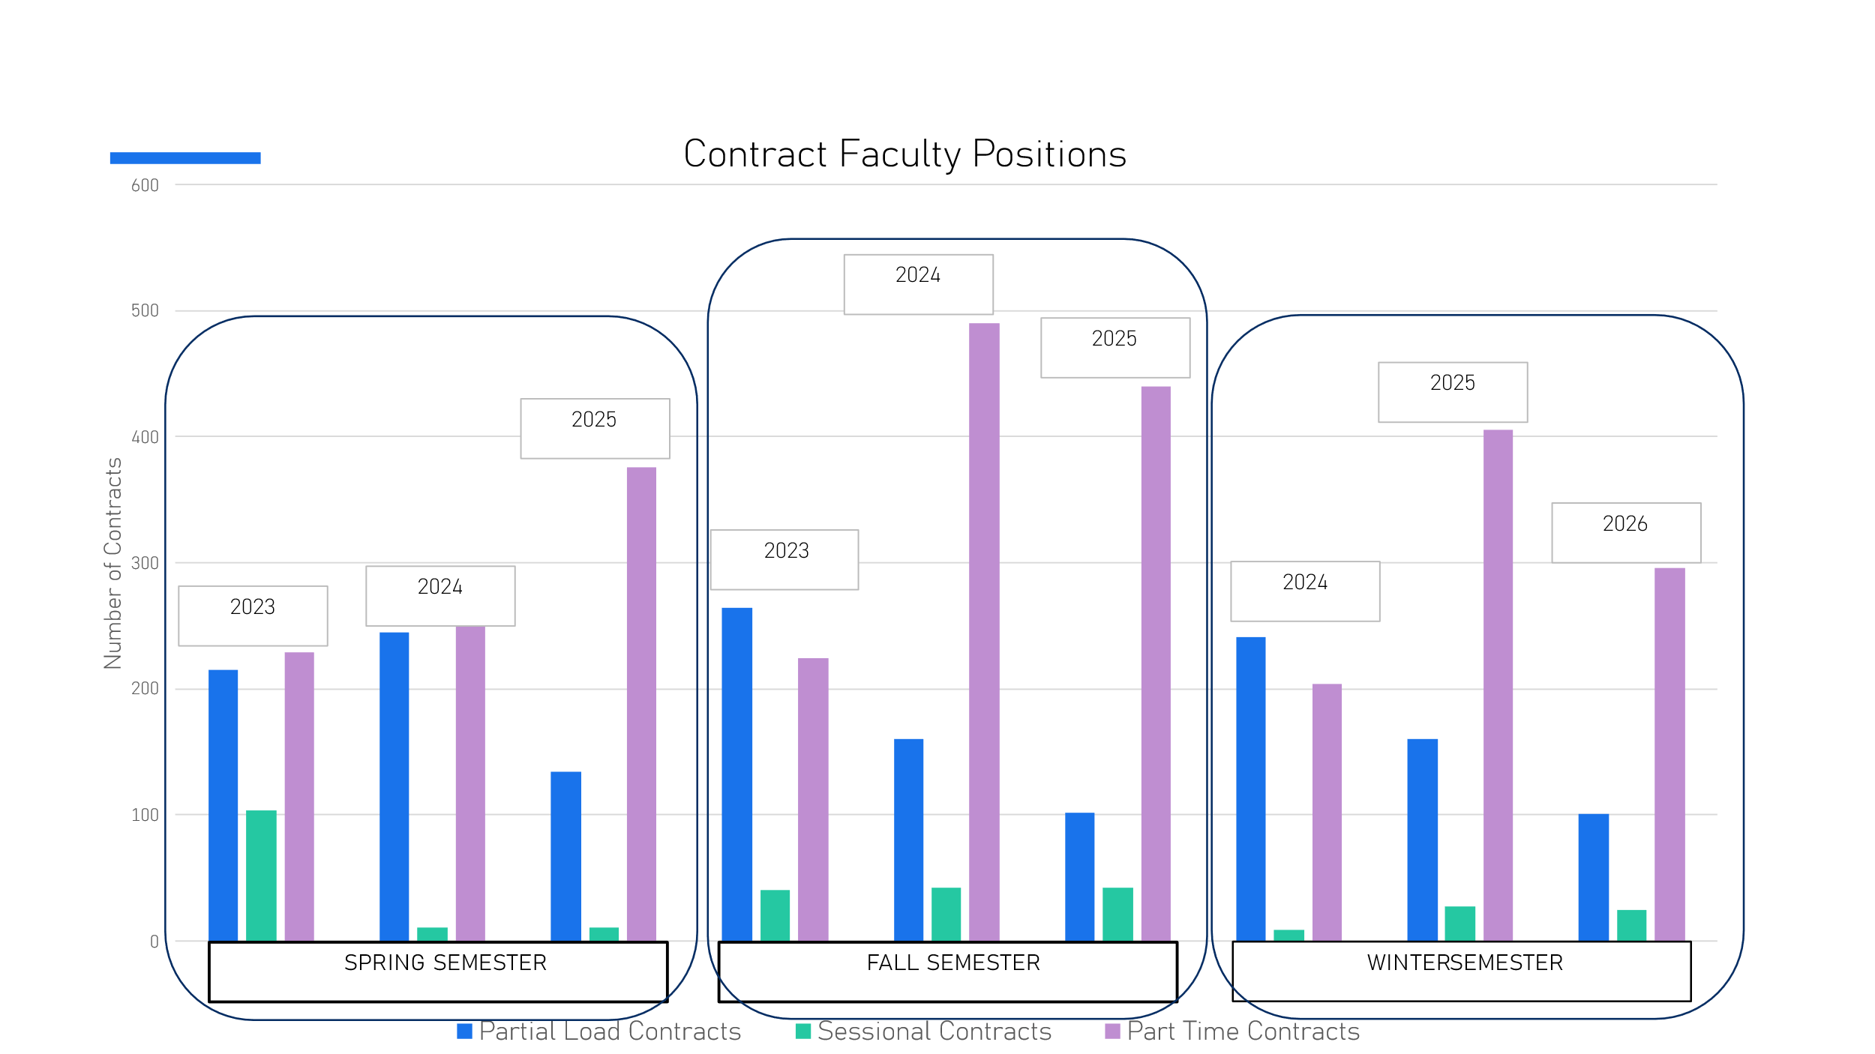

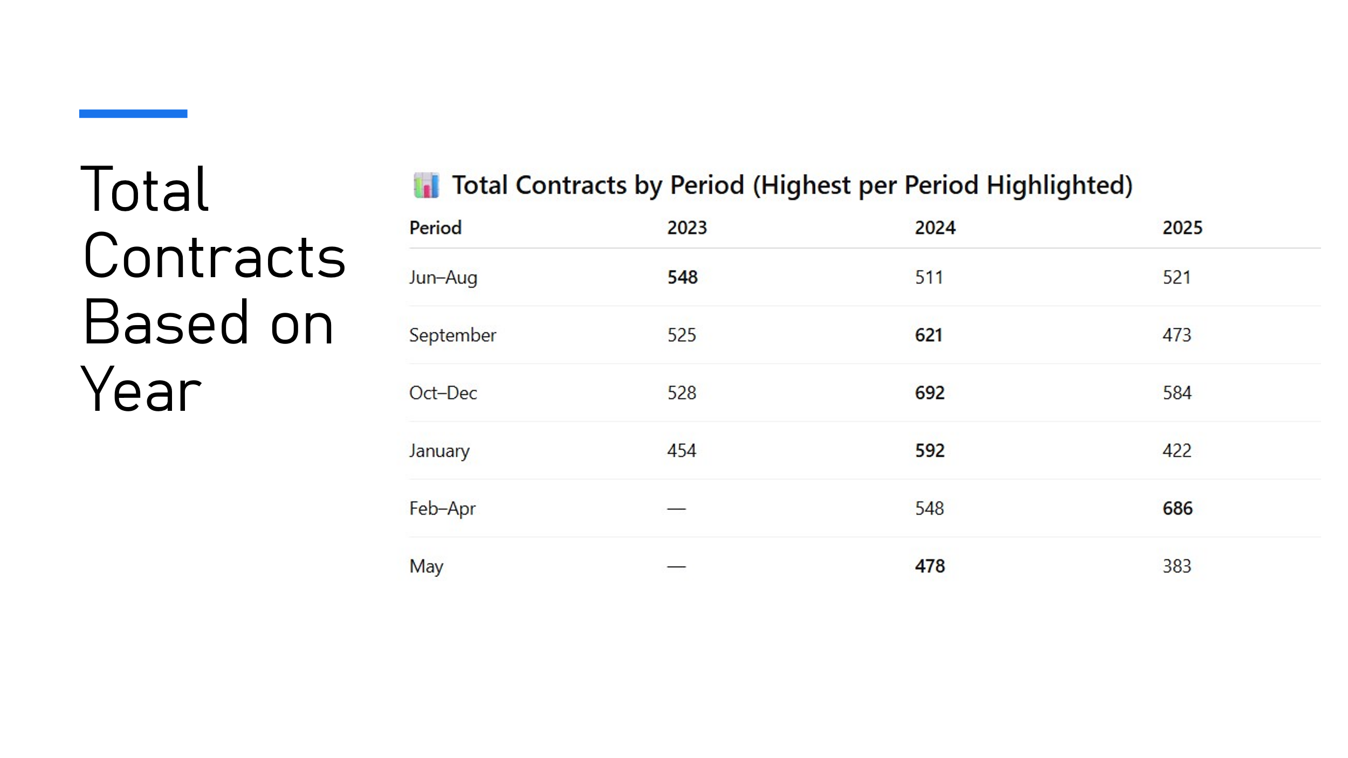

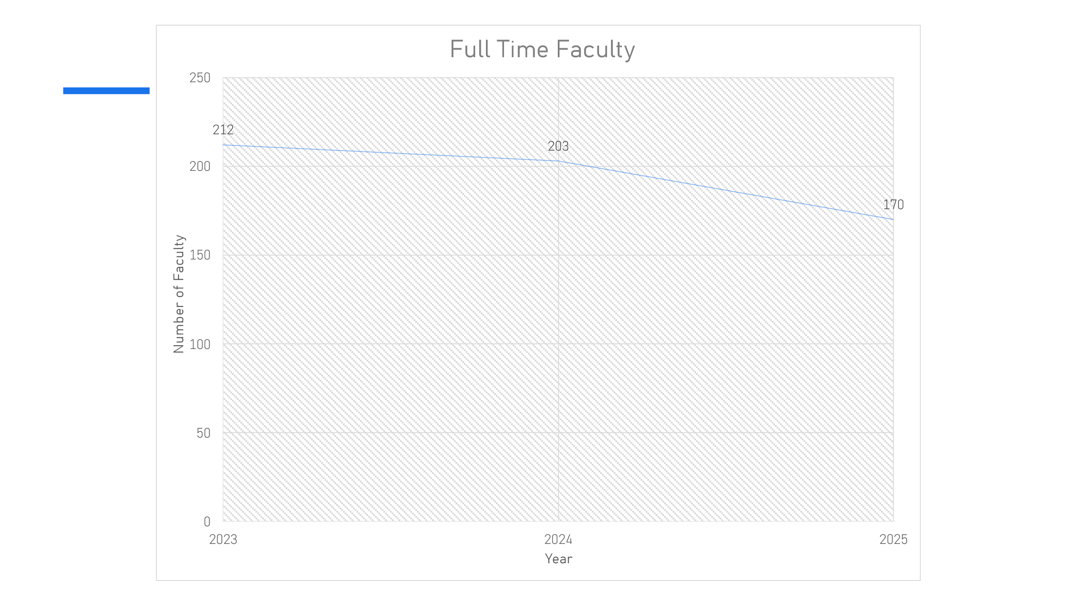

6. College Employment Stability Committee (CESC) – Mike & Kari

- 2 recent meetings with management
- Bumping opportunities with relevant experience
- After Open House, 5% of our membership is in employment stability
- No new program cancellations, but enrollment is very low – not financially viable to maintain some programs
- Waiting for arbitrator to give new ruling whether Case Law will be upheld (re: members choosing severance). By choosing severance, members are choosing to sever their job and therefore cannot grieve it (or any previous grievances).

7. Elections

- Release time of Local 352 officers needs to be forwarded to management by June 1st, 2026

    - President

- Kim Bell nominated Mike Benedict; Mike accepted.
- No further nominations.
- Mike Benedict was elected by acclamation.

    - 1st Vice President

- Nancy Sukornyk nominated Kim Bell; Kim accepted.
- Bill Templeman nominated Tom Jenkins; Tom declined.
- No further nominations.
- Kim Bell was elected by acclamation.

    - Treasurer

- Charlie McGee nominated Kari Draker-Fortis; Kari accepted.
- No further nominations.
- Kari Draker-Fortis was elected by acclamation.

    - Secretary

- Kim Bell nominated Nancy Sukornyk; Nancy accepted.
- No further nominations.
- Nancy Sukornyk was elected by acclamation.

- 2nd Vice President

- Nancy Sukornyk nominated Ann Hines: Ann accepted.
- No further nominations.
- Ann Hines was elected by acclamation.

8. Service Awards

- 21 faculty received service awards for 5, 10, 15 & 20 years of service

Adjournment

Moved: Charlie
Second: Ann

